First Step Requirement

1. Read The documentation ( Mobile Application Coding Challenge). I found the objective, design and requirement

2. Need BitBucket Repository

3. No Third Party

Design

1. Create Prototype Application. I Implement using UIViewController and UICollectionView.

2. Design Architecture using MVVM (Model View View Model)

3. Using CoreData: Create Entity NewsFeed and User, It is have relationship one to many.

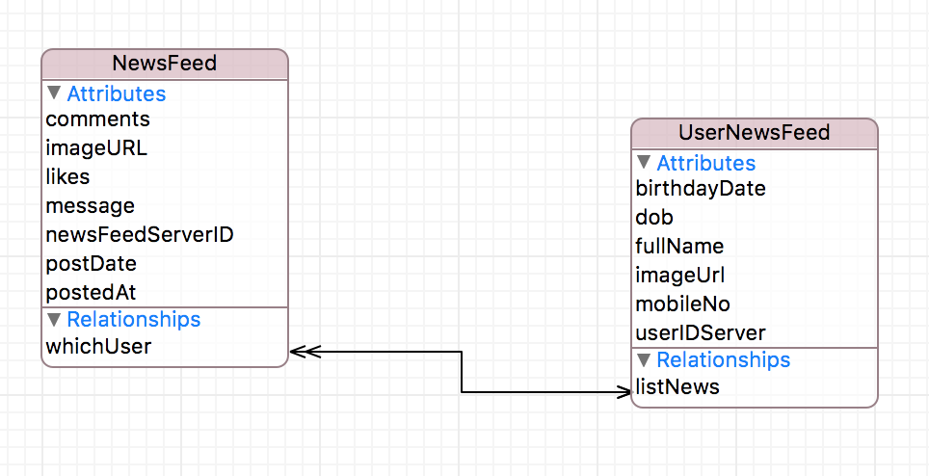

4. Save the image in the memory

Implementation

1. Create UiCollectionVIewCell Dummy design
2. Test Rest API
3. Create NewsFeedModel to handle process Query to Server, CoreData and etc.
4. Create Fetching for handle Query Server.
5. Create Global Constant and Extension (like handle date difference)
6. After Create News Feed get count Likes and Comments
7. Handle Refresh Controll and Background
8. Default Image
9. Follow The Design

Testing

Test using UI unit test

Final

1. Commit to bitbucket